Our Mission:

Kirby Medical Center is committed to providing quality and compassionate care to all.

Our Vision:

Kirby Medical Center will be the market leader in providing accessible, high-quality healthcare that consistently exceeds our customers’ expectations. We will be stewards of our communities by developing and providing services that make Piatt County and surrounding areas healthier places to live.

Welcome to Kirby

The culture at Kirby Medical Center sets us apart from other organizations. By aligning our goals and ensuring everyone at Kirby maintains the same high standards for themselves and their coworkers, we all succeed.

Core Values

Kirby Medical Center is a “values-based” organization, which means we have prescribed core values and behavior standards that drive us as a hospital and determine our future success.

Saying we are values-driven is easy to do. Actually modeling our values takes the commitment of every person who works here at Kirby. Our organization is enhanced because we create and maintain a culture that supports us through the many and varied challenges in healthcare.

COMPASSION

Being mindful of the feelings we emote and how

**CARES**

**COMPASSION**

Being mindful of the feelings we emote and how we interact with each other and our customers.

**AT T I TUDE**

Always present a good attitude when dealing with our customers and coworkers, no matter the circumstance.

**RESPECT**

Know and practice that each individual is worthy of being treated with fairness and equality.

**EXCEL LENCE**

Perform ordinary things in an extraordinary way.

**STEWARDSH I P**

Become efficient with our time and resources while passing our Core Values on to others.

The Five Pillars of Excellence

The many goals of Kirby Medical Center are organized under the following pillars.

Each pillar is fundamental to our success as an organization:

Service

• Improving access to services and facilities

• Increasing patient satisfaction scores

• Enhancing referring physician satisfaction

• Focusing on customer service

People

• Offering ways for employees to advance their education

• Developing employee reward and recognition programs

• Improving communication at all levels

• Increasing employee recruitment and retention

Quality

• Enhancing quality of care

• Increasing patient safety

Financial

• Sustaining a strong financial position

• Focusing on development and fundraising

Growth

• Developing long-range plans for facilities

• Focusing on partnerships and relationships

• Expanding services offered to the community

YOU play an important role in helping to achieve our goals and fulfill our mission.

YOU are the most powerful and important resource we have.

We need your help to help us promote Kirby Medical Center and share our many services.

To have people know about us.

To have people know about us,

Who are willing to tell others about us.

Who will support us

Who will support us

Because we support them.

They are called advocates.

Of course that does not happen overnight.

It starts with:

* Awareness
* Familiarity
* Image
* Preference
* Utilization
* Advocacy

So how are we building AWARENESS?

MARKETING

Our job is to use research to understand the consumer

Then form a strategy that connects with the consumer

And put messages out in the communities we serve.

Kirby Medical Center

(ad campaign marketing samples below)



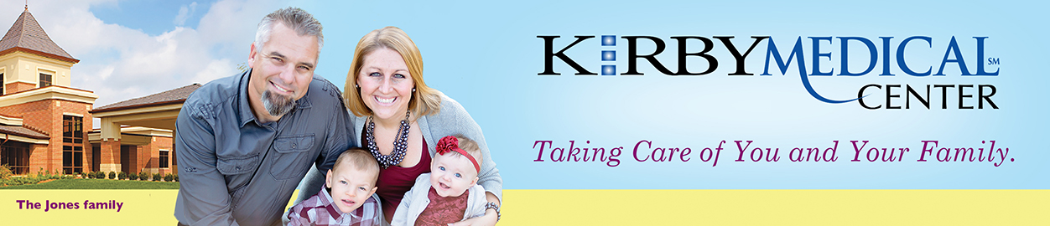

<https://youtu.be/q3-hNA4XELk>



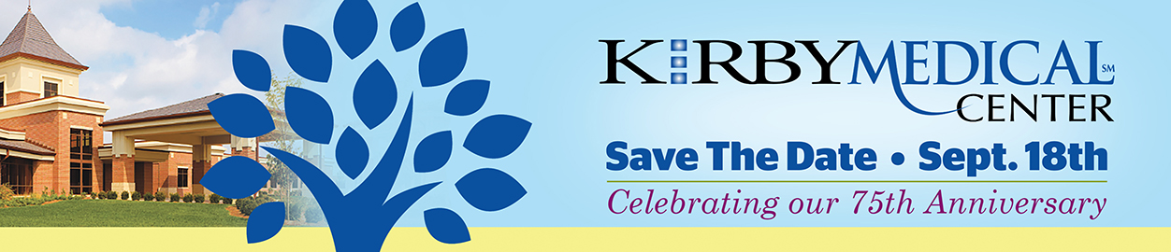

<https://youtu.be/-yEd_yZPl34>



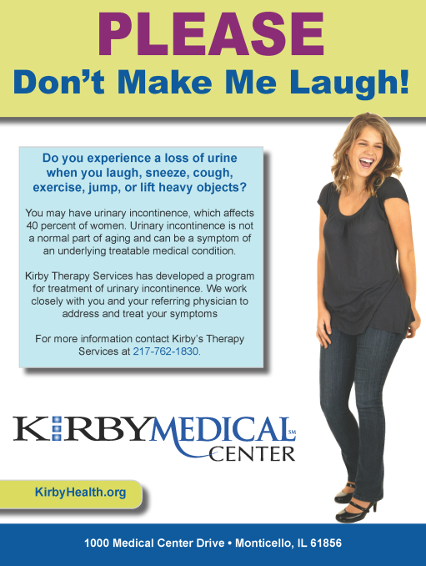

Give Thanks Campaign

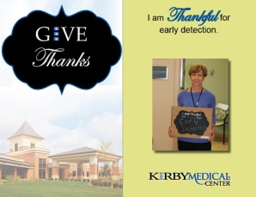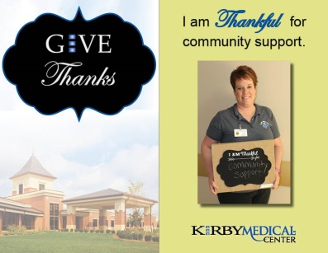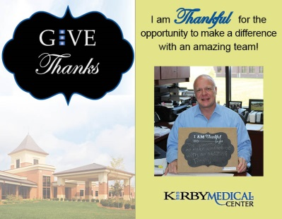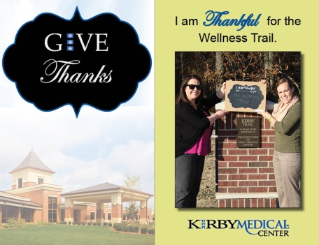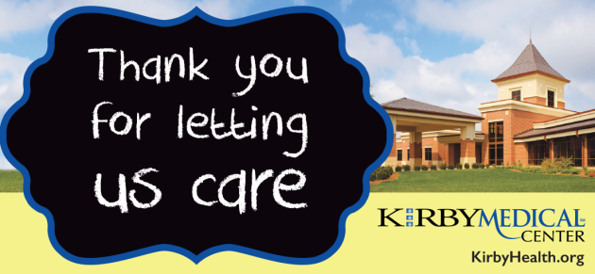

Give Thanks Video: <https://youtu.be/BwvRe3DyEGs>

(Video clips/commercials)

Give Thanks Video: <https://youtu.be/BwvRe3DyEGs>

Kirby’s Story Video: <https://www.youtube.com/watch?v=wpbC4Wg8kME>

Kirby’s History Video: <https://youtu.be/nZn-82MGFzE>

(images of events, ribbon cutting, employee events, in the community)





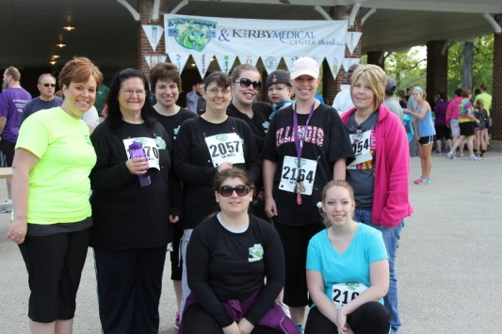

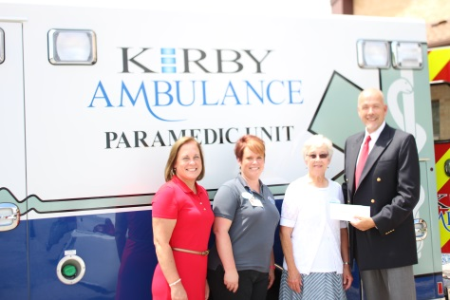



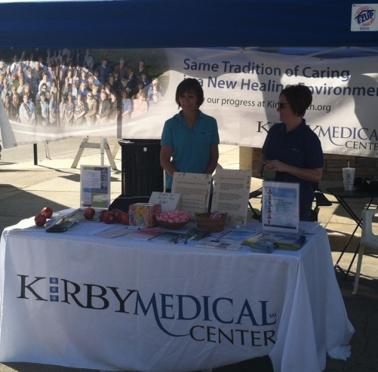

Billboards

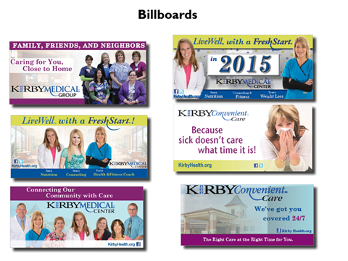

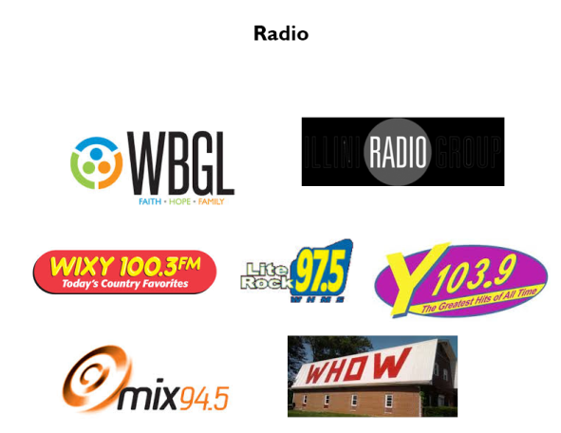

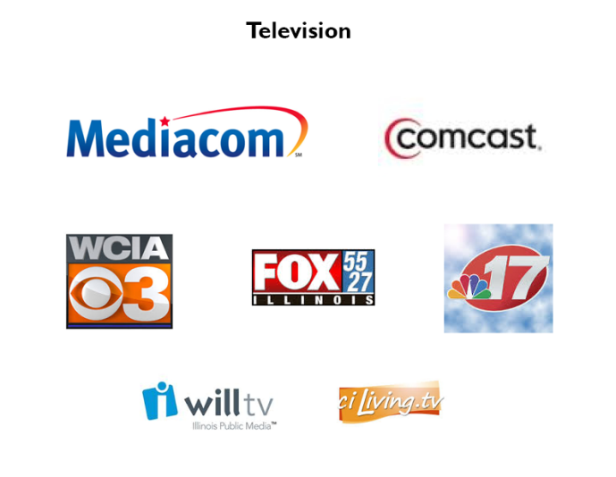

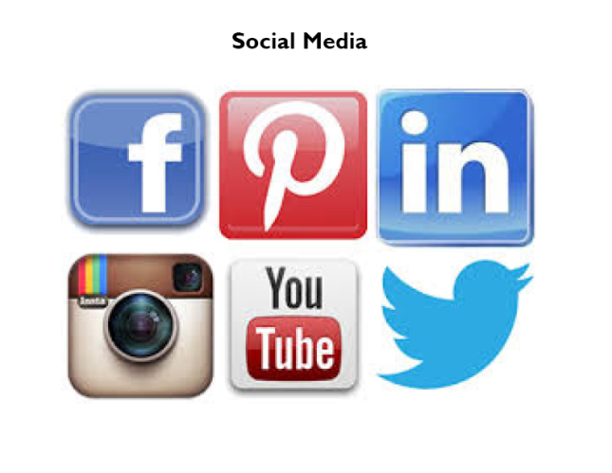

And while we create the messages,

Which drive awareness.

Which in turn generates

Phone calls

Which in turn generates

Website visits

Which in turn generates

Patient visits

It’s up to all of us

To make that next step.

Because better employee engagement with the mission

Because better employee engagement with the mission leads to better patients experience.

Maybe you’ve seen some of these internal communications:

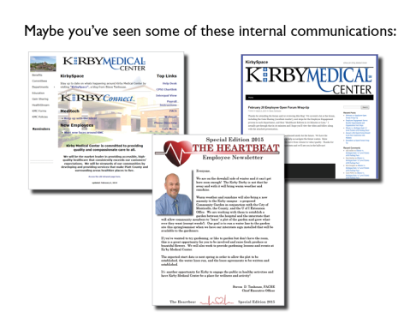

Just remember, you play an important role.

Connect with Kirby Medical Center

Connect with Kirby Medical Center

(Facebook, Twitter, LinkedIn, Intranet, Employee Forums, Pinterest, Instagram, etc…)

Review Kirby on Healthgrades, Facebook, Google+, etc….

TELL US YOUR STORY.

Our staff and caregivers set Kirby apart and define Kirby culture.

As a Kirby employee, you are part of the Kirby family and our long history of local care. You have the power to represent

How are you going the extra mile? How do you focus on the details?

We are going the extra mile, to connect the community with care.

Kirby Medical Center.